Ch1 – AI in Azure

AI Workloads
- Prediction/Forecasting
  - Ideal when answering either/or questions.
  - Binary (e.g. true/false, yes/no)
  - Qualify for a loan? Yes/no
- Anomaly Detection
  - Imbalanced, fraud, etc;
  - Something that is rare or out of place in the data
- Computer Vision
  - Visual input from Images, Video, cameras
  - Often more accurate then humans at image analysis
  - Examples – facial recognition, cancerous tumors, etc;
- Natural Language Processing and Knowledge Mining
  - Words, phrases, publications, wiki's
  - Infer context of written text
  - Examples – chatbots, spell check, proofreading
- Conversational AI
  - Audio, words, publications, wiki's
  - Human like dialogue, chatbots
- There is some overlap between NLP and Conversational AI

Ch2 – Responsible AI

AI Considerations (FRP ITA)
- Fairness
  - Reducing biased data, discrimination, societal stereotypes
  - Ensuring diversity
  - Sociotechnical challenges
- Reliability and Safety
  - Consistent with a guiding set of values and principles
  - Handling of unusual of missing values provided to an AI system
  - Systems and models are not creating harm in the world, they operate as intended, resist harmful manipulation
  - Example - self driving cars can cause harm to human lives
- Privacy and Security
  - MS believes privacy is a fundamental right
  - Not removing the data from a customers device and instead run the models locally on the customers device
  - Anomaly detection
  - Data classification and proper storage for that data
- Inclusiveness
  - empowering all
  - engaging everyone
  - solutions should work for everyone
- Transparency
  - transparent about issues, bugs, and risks of their AI solution
  - mitigating unfairness
  - gaining trust from consumers
  - documentation to help devs debug code
  - understanding the behavior of AI systems – interpretability/intelligibility
  - ethical values of AI solutions
- Accountability
  - providing solutions to the problems our AI has introduced
  - help customers and partners be accountable when using AI systems
  - ethical and legal standards should be defined
  - advocate for regulation in facial recognition
  - decision can be overridden by humans
  - clear goals and clear liabilities
  - who is liable/responsible for AI-driven decisions when something goes wrong?

Ch3 – Machine Learning

- M/L is creating predictive models by finding relationships in data

Machine Learning Scenarios
- Regression
  - uses supervised learning to predict numerical output data
  - Example – bike rental company; as temps go up, so do bike rentals
- Classification
  - uses supervised learning to predict several values; The data is then categorized using different labels, and the labels help to make predictions for the data
  - Example (binomial) - output is one of two possibilities (0-no, 1-yes)
  - (Can also be three of more)
  - A threshold value must be determined to divide outputs
  - Example – loan; high risk or low risk
  - Example – predict whether a student will finish a college course
- Clustering
  - unsupervised learning that partitions the data into logical groups
  - used to derive meaning from unstructured data
  - we do not have the output variables (labels)
  - data can be very vague (Example – flowers that look similar)
  - Example – segment customers into different groups to support a marketing dept

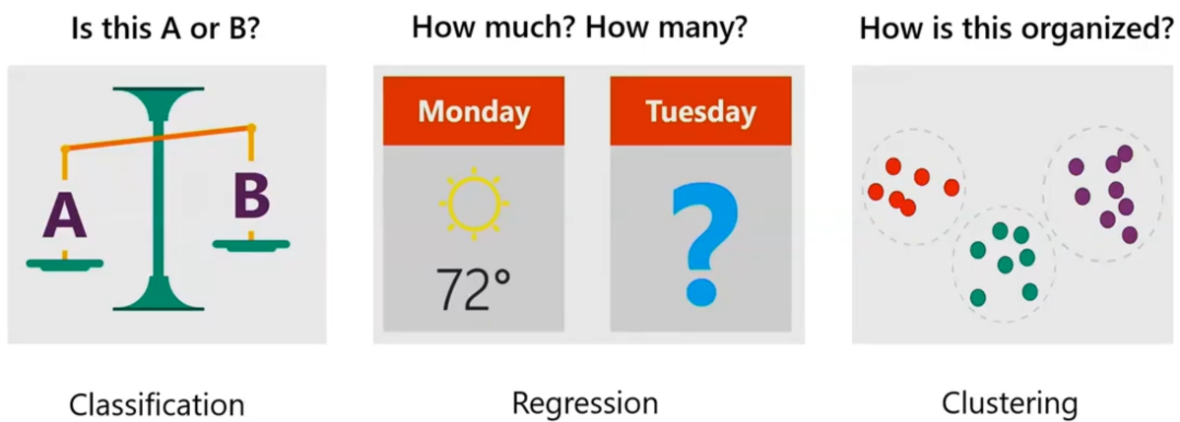

Supervised Learning (decision boundary)
- dataset consists of labeled examples, and each example consists of features
- Example - cat vs non cat
- The features are analyzed, and the outputs are labeled
- Dataset is divided into training set and validation set

Unsupervised Learning (patterns)
- input data points have no labels associated with them
- algorithms attempt to organize the data to determine patterns or a structure to the data
- groups data into clusters
- analyzes relationships in the data and finds hidden patterns to define new labels
- allows the user to define new labels based on what the AI model has found

Semi-Supervised Learning
- dataset contains labeled and unlabeled examples
- The goal is to leverage unlabeled cases to improve the reliability of the model
- Done by running the model using labels cased and then again using unlabeled cases

Reinforcement learning
- builds a prediction model by receiving feedback from trial and error
- a goal (target) is defined so the model can know if it is improving
- making the best decision possible using the data we have
- real time decisions
- Example – google maps shortest route form point A to point B
- Example – the goal is to label 95% of duck images correctly, then the model will try various methods until it hits that 95% mark

Ch4 – M/L Concepts

Dataset
- A logical grouping of units of data that are closely related

Features and Labels in a Dataset for ML
- feature is a measurable characteristic
- After your model has completed training, you receive an output called a label
- Example - M/L would look at the features of a person’s eyes, nose, mouth, and hair and then assign a label as male or female
- More specific example – M/L would assign numerical values to each feature analyzed and then the total score would determine male or female
- Features imply the label

Training and Validation Datasets in ML
- A training dataset is a dataset that we use to train the model
- A training set enables the machine learning algorithm to "learn" relationships between the features and the target variable
- A hyperparameter is a parameter whose value controls the learning process
  - You tune hyperparameters in a Machine Learning model before applying an algorithm to a dataset just as you tune a violin before playing music.
- The validation set evaluates a given model; And the evaluation is repeated to fine-tune the hyperparameters of the model in order to improve on it
- A testing set follows the same probability distribution as the training dataset.
- For M/L progress, we randomly split data into 2 rows - 1 row training and 1 row evaluation

ML Algorithms for Model Training
- Machine Learning algorithms find patterns in the training data that correlate the input data to the target
- You provide ML model with training data that contains the files for which you already know the answer
- ML would use this data to make predictions on new data

Model Evaluation Metrics for Classification and Regression
- ML models need evaluation metrics ensure that you understand the actual performance of your model

Classification Related Metrics
- requires an evaluation to ensure it is accurate
- Can be evaluated using a true positive rate
Confusion Matrix
- aka error matrix
- a tabular visualization of the model predictions in comparison to actual labels.
- Each row represents instances in a predicted class, and each column represents the instances in an actual class

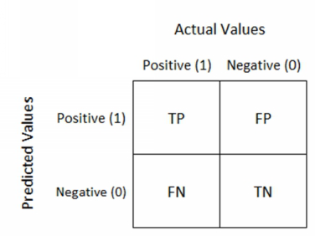

- TP = True Positive = Images that were the target class and classified correctly by the model as matching it.
- FP = False Positive = Images that were not the target class and misclassified by the model matching it.
- FN = False Negative = Images that were the target class and misclassified by the model not matching it.
- TN = True Negative = Images that were not the target class and classified correctly by the model as not matching it.

TP = Target class classified correctly
FP = Not the Target class misclassified
FN = Target class misclassified
TN = Not the Target class classified correctly

Classification Accuracy
- Classification accuracy is correct predictions divided by the total number of predictions, multiplied by 100
- Classification accuracy = (true positive + true negative)/total

Precision
- a metric that works well with imbalanced data
- Precision= True_Positive/ (True_Positive+ False_Positive)
- In the cat/non-cat example, we would calculate both cat classification precision and non-cat classification precision to determine if the model were more precise in predicting both cats and non-cats

Recall
- Aka Sensitivity
- the fraction of samples from a class that is correctly predicted by the model.
- Recall= True_Positive/ (True_Positive + False_Negative)
- In the cat/non-cat example, we calculate both cat and non-cat recall

F1 Score
- Measures Both recall and precision by combining them into a single metric called the F1-score.
- Takes both false positives and false negatives into account
- F1-score= 2*Precision*Recall/(Precision+Recall)
- Correlation between precision and recall of a model – as recall goes up, precision goes down

Sensitivity and Specificity
- Sensitivity is the percentage of actual positive cases predicted as true positive.
- Sensitivity = (True Positive)/(True Positive + False Negative)
- Specificity is the proportion of actual negatives predicted as true negative
- Aka the false-positive rate
- Specificity = (True Negative)/(True Negative + False Positive)

ROC Curve
- How we evaluate a classification model
- The ROC curve is displayed after plotting the true positive rate (TPR) against the false positive rate (FPR) using various threshold settings.
- A ROC curve helps with model performance by enabling you to pick an excellent cut-off threshold (between 2 labels such as cat/non-cat) for a model
- A ROC curve in the top left corner with 100% TP rate and 0% FP rate will be the best model
- A ROC curve that is flat from the bottom left to the top right corner when using random data
- A ROC Curve that is worst than random would dip below the y=x line

AUC
- The area under the curve
- the probability that the model will rank a random positive example higher than a random negative sample
- a number between 0 and 1
- The higher the AUC, the better the model is

MAE
- Mean absolute error (or mean absolute deviation) finds the average absolute distance between the predicted and target values
- Lower score is better

MSE
- Aka ‘Mean squared error’
- finds the average squared error between the predicted and actual values
- Summarizes the error in the model

Ch5 – Core Tasks

Data Ingestion and Preparation
- the method in which data is extracted from a source or sources and prepared to train machine learning models
- very time intensive
- exponentially more time to prepare the data when performed manually
- Examples of preparing data -
  - Convert categorical data to numerical (from decimal to binary)
  - Change data types (from int to string)
  - Address missing data
  - Converting timestamps
  - Remove unneeded rows or sols
  - Remove unwanted characters

Feature Selection and Engineering
- Feature selection is the process by which you prune the field of data down to the most valuable inputs, which in turn improves training performance
- Also selecting pertinent and suitable features to use in building an analytical model
- Feature engineering is creating new features out of existing data

Filter Based Feature Selection
- Filter based feature selection is so-called because you are choosing the relevant columns which enable you to build the best scores to build your predictive model
- Input: Dataset
Output: Filtered Dataset with feature selection scores

Fisher Linear Discriminant Analysis
- Aka discriminant function analysis
- the act of classification by distributing things into groups, classes, or categories of the same type
- discovers a linear combination of features that characterizes or separates two or more classes of objects or events
- Input: Dataset
Output: Transformed features

Permutation Feature Importance
- Feature values are randomly shuffled one column at a time; And the result is more essential features having a more significant impact on the shuffling process and thus, resulting in higher importance scores
- Input: Trained model or test data
Output: Feature importance

Model Training and Evaluation
- in the training process, rows with missing values are skipped
- Implementing the Azure ML Clean Missing Data module before training can rectify this problem
- Can also use Edit Metadata module, which fixes issues within the data, such as adapting column names or changing data types

Choosing the Right Trainer
- Sweep Clustering: Determines the ideal settings for a clustering model.
- Train Clustering Model: Trains a clustering model.
- Train Anomaly Detection Model: Trains an anomaly detector
- model.
- Train Matchbox Recommender: Trains a Bayesian recommended using the Matchbox algorithm.
- Train Model: Trains a classification or regression model.
- Tune Model Hyperparameters: Determine the ideal parameter settings for regression or classification model.

Evaluate
- We evaluate a model to determine whether the predictions are accurate and whether overfitting occurs (analysis corresponds too closely to a set of data)
- Microsoft Azure has an evaluate category with the following modules:
  - Cross-Validate Model: Select this module when you want to test the validity of your training set and the model.
  - Evaluate Model: Uses standard metrics to evaluate a scored classification or regression model.
  - Evaluate Recommender: Provides an evaluation of the accuracy of the recommender model.

Model Deployment and Management
- Model deployment is the process for making your models available in production environments, where they can provide predictions to other software systems
- Deployed models are typically a software library that can be accessed either via a client application or within a server-side environment

Ch6 – No Code Azure M/L

Automated Machine Learning Tools
- Azure M/L allows anyone to create and customize models via a user interface (non-CLI)
- Different portal than Azure (ml.azure.com)

AutoML or
- repetitive and time-consuming tasks in Machine Learning that can be automated
- given a target metric by the user, AutoML can train and tune a model
- works by creating multiple parallel pipelines that try various algorithms and parameters, the resulting score showing which model is best for your data
- can include custom Python scripts in a training pipeline
- no coding experience necessary
- user must supply data, constraints(time/cost) and optimization metric, and Azure M/L will find the best model

vs. Azure Machine Learning Designer
- visually connect models and datasets
  - Can drag datasets and modules onto the canvas
- Similar to MS Visio or Azure Logic Apps (drag and drop)
- Use a training pipeline to train and evaluate a model
- Use inference pipeline to predict labels from new data
- We publish an inference pipeline as an API Service
- Users need 2 parameters to consume the pipeline – the authentication key and the REST endpoint
- To deploy a real time inference pipeline as a service for others to consume, you must deploy the model to Azure Kubernetes Service (AKS) or Azure Container Instances (ACI)

Ch7 – Computer Vision

Image classification
- accepts the given input images and produces output classification identifying whether something is or is not present in the image
- used for a single object
  - Example - an image can be classified as cat, truck or dress

Object detection
- find the coordinates for multiple objects found in an image while also processing relationships between images or determining if there are numerous instances of the same object in an image
- image, object(s), confidence level
- find specific objects in an image so you can estimate the distance between them

Semantic Segmentation
- Goes one step farther by identifying objects at a pixel level
- Will color pixel to signify what objects are in the image
- Can determine exact coordinates (pixels) of an object within an image

Optical Character Recognition
- converts typed, handwritten, or printed text into machine-encoded text
- the source is typically a photo or hand-written document
- useful for converting pdf text to other file formats

Facial Detection
- can identify a person from a digital image or a video frame
- analyzing patterns based on the individual's facial textures and shape

Image Analysis (With the Computer Vision Service)
- Over 10,000 predefined classes
- Face detection and analysis
- Text detection and OCR
- Can detect objects and identify relationships between objects

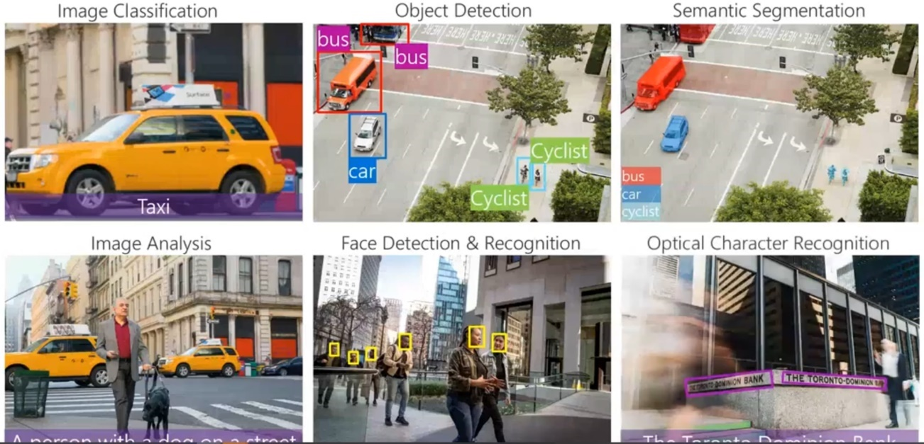

Ch8 – Azure tools and services for Computer Vision

Computer Vision
- Pre-trained computer vision model
- Includes face detection
- includes Optical Character Recognition (OCR)
  - OCR extracts text from images and Documents
- The Read API can extract text from documents in seven different languages or handwritten text in English, including digits and some symbols
- Steps:
  - Upload/input the document or image.
  - Read API accepts the image and returns an operation ID.
  - Get Results operation associates the extracted text with the
- OCR API – small amounts of text
- Read API – large amounts of text
- Pre-trained computer vision model that cannot use custom images
  - Object detection for over 10,000 predefined classes
- Can Detect faces in an image and recognize handwritten text (via OCR)
- Can detect brands in an image and detect the color scheme in an image

Custom Vision
- uses an algorithm to apply labels to images
- Once known, new images are labeled as cat or non-cat based on what was learned from the test data.
- You can divide Custom Vision functionality into two features: Image classification and object detection
- Can use custom images
  - Unlike Computer Vision, Custom Vision allows you to specify the labels and train custom models to detect them
- Use for training or prediction
  - If you select both, it will create 2 resources (one for each)
- Can select from a set of predefined domains
- Outputs are in JSON

- Image classification can apply labels to an image while object detection can identify the coordinates where the labels can be found

Face
- Cognitive Services offers a service simply called "Face" that leverages algorithms to detect, recognize, and analyze human faces in images
- Face service can group all people in an image that have similar facial characteristics
- The detect operation in the Face API uses coordinates of each face in the picture
- The Verify API can detect if two faces belong to the same person.
- The Group API divides a group of unknown faces based on similarity
  - Faces that belong together
- The Identify API identifies a face against a database of people or in a picture with a group of people

Form Recognizer
- can identify and extract text, key/value pairs, and table data from pdf documents
- The input is the text from forms, and the output is structured data and relationships between the data
- Models perform semantic recognition of forms fields not just text extraction
- Example – extract subtotals and totals from a receipt
- comprised of the following services:
  - Custom models - Extract key data from forms.
  - Prebuilt receipt model - Extract data from receipts.
  - Layout API - Extract text and table structures from documents.

Ch 9 – Natural Processing Language (NLB) workloads

Key phrase extraction
- the task of assigning key phrases to documents to capture the main topics
- Key phrases, key terms, key segments, or just keywords are the terminology which is used for defining the terms that represent the most relevant information contained in the document
- Example – a doctor wanted to find all of the articles published in the medical school archives regarding a specific disease.

Entity recognition
- Entity recognition is the automated task of locating and classifying named entities in unstructured text into categories.
- The categories are predefined, such as locations, codes, quantities, etc.
- Extract persons, locations and organizations from text

Sentiment analysis
- uses natural language processing, text analysis, linguistics, or biometrics to quantify affective states or the sentiment of the source
- evaluates text along a positive-negative scale

Language modeling
- the process of developing probabilities for word sequences.
- especially useful to voice recognition systems

Speech recognition and synthesis
- the discipline of developing methodologies and technologies that enable the recognition of a spoken language into text by a computing system
- Synthesis is the ability of that system to make language easily understandable.
- Speech recognition Example - Providing closed captioning for videos
- Speech recognition Example - Creating a transcript of a phone call or meeting

Translation
- The newest methods analyze the most likely translations and rank them by using statistical analysis

Ch 10 – Azure Tools for NLP workloads

Text Analytics
- provides natural language processing leveraging machine learning and AI algorithms in the cloud. The Text Analytics API provides four types of analysis:
  - Sentiment Analysis - Microsoft provides analysis models that are pretrained using natural language technologies from Microsoft
    - Measures confidence (example - 88% positive)
  - Key Phrase Extraction – key talking point
  - Language Detection – The API can detect which language is input and provide a score indicating confidence level. (NaN – can’t decipher language)
  - Named Entity Recognition - Identify and categorize entities in your text (e.g., date/time, people, places, things, etc.)

Language Understanding Intelligence Service (LUIS)
- LUIS leverages machine learning to predict the meaning within the text and extracts relevant information
- Detecting intent (ie - instructions that you want your app to recognize)
- Entities are the dynamic variables (city, airline, data number of tickets, etc)
- Example - it can analyze text from applications, social media, chatbots, and any other platform that leverages natural language and responds accordingly.
- Example – “turn on the light”, “text me later”, “book a flight”

Speech
- Real-time Speech-to-text
  - Transcribes or translates audio streams or local files to text in real time.
- Batch Speech-to-Text
  - Transcribes or translates large volumes of speech audio data.
- Multi-device Conversation
  - Transcription and translation support for multiple clients in a conversation.
- Conversation Transcription
  - Real-time speaker identification and speech recognition.
- Create Custom Speech Models
  - Train custom models to meet industry specific language or environmental challenge (such as a construction site).
- Text-to-speech
  - Converts input text into human-like speech.
- Create Custom Voices
  - Create custom voices for your brand.
- Speech translation
  - Real-time speech-to-speech and speech-to-text translation.
- Voice assistants
  - Human-like conversational interfaces for applications and bots.
- Speaker verification & identification
  - Verify and identify speakers.

Text Translator
- Translate text or voice
- enables you to support multi-language user experiences.
- includes language detection, translation, transliteration, and dictionaries.

Ch11 – Conversational AI

- Alexa questions such as “what Is the weather like?”, “who is the tallest person on the planet?”
- Enables a dialogue between AI and human

Webchat bots
- a software application used for online chat conversations with an automated system.
- Its goal is to provide quality information via an interface that is similar to human behavior.
- They are typically used for customer service or information gathering.
- Example – answer q’s about scheduled event and ticket purchases for a music festival
- Example – a bot that responds to queries by internal users
- Example – submit request to reset password

Telephone Voice Menus
- Aka auto-attendant
- allows callers to obtain information or transfer to an extension without going through a receptionist

Personal Digital Assistants
- PDA can give access to almost anything a computer can, while also typically allowing access to a wide array of applications

Ch12 – Azure Services for Conversational AI

QnA Maker Service
- QnA Maker is a Natural Language Processing (NLP) service that enables you to create a conversational layer over your data
- Creating a knowledgebase
  - A knowledgebase can provide the same answer to different users who ask a similar question
- For example, if someone asks a question via social media, chatbot, or speech-enabled application, your data can be queried, and a response given in a natural human tone
- Results in JSON
- Consume the knowledge base from clients apps, including bots
- Can generate question and answers using an existing webpage
- Can manually enter the q’s and a’s
- Can import chat-chat content from a predefined data source

Bot Framework
- A customizable web-based client
- A seamless solution, allowing you to create a bot in just a few steps
- integrates with your website, including allowing for customization for your brand.
- Framework to develop, manage and publish a bot

Azure Bot Service
- Can communicate by email, MS Teams, webpage
- Active learning
  - Improve relevance of responses over time
- Can be integrated with Azure Cogs Service
- Can be integrated with LUIS, QnA Maker, etc;

- Bots can engage over web chat interfaces, email, social media, and voice

Responsible bot guidelines
- Be transparent - make it clear that the user is communicating with a bot

AZURE Services review

Many/Multiple
Cognitive Service
- 1 endpoint
- Single service to do many things
- MS Suite for AI
- Has pre built ML models
- An App would need an authentication key and REST Endpoint to consume cogs services
- (Cogs service is essentially an API)

Specific/Separate Keys or Endpoints
Computer Vision (included in Cognitive Service)
- Pre built
- No training
- Includes OCR
- Can’t use you own images

Custom Vision (also included with Cognitive Service)
- Unlike Computer Vision, Custom Vision allows you to specify the labels and train custom models to detect them

Face Service (also included with Cognitive Service)

Forms Recognizer (NOT included with Cognitive Service)
- 20Gb max size

Text Analysis Service

Speech service (included with Cognitive Service)
- Text to speech, speech to text, speech to speech

Translated Text (included with Cognitive Service)
- 60+ languages
- Profanity filter
- Selective (example - don’t translate certain words such as a brand name)

Language Understanding (included with Cognitive Service)
- Authoring or prediction

QnA Maker (NOT included with Cognitive Service)
- Knowledge base (Question and Answer pairs)

Azure Bot service (NOT included with Cognitive Service)

Azure M/L

Azure ML Workspace
- A logical container for resources you need to manage for your M/L projects
  - Compute is one of the more important resources
  - Data
  - Experiments
  - Models
  - Services (accessed over http connections)

